MAPA Meeting – May 30, 2023
Recent and Upcoming Policy Changes

Engineering Policy Changes

- EPG 450: is being updated to reflect a change in policy to increase the minimum lift thicknesses for Superpave and Bituminous Pavement mixes. This will reflect NCHRP’s recommendations for using four times the nominal maximum aggregate size, as a basis for the pavement lift thickness.

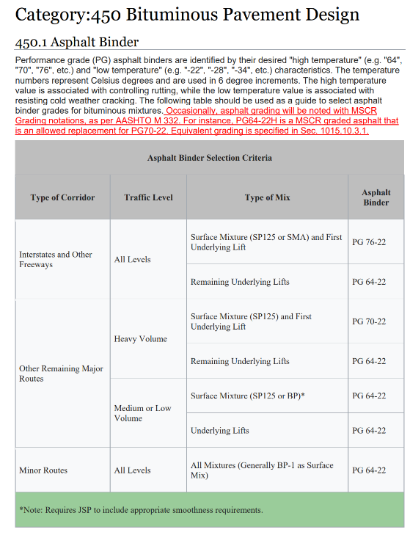
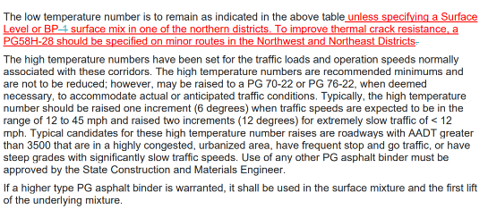
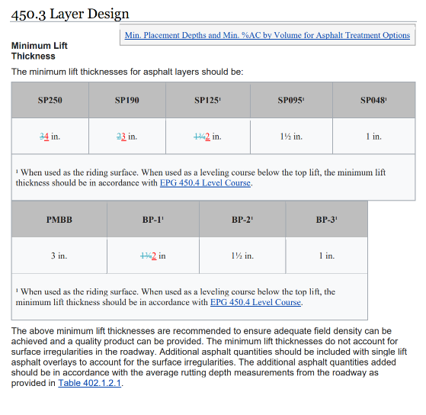
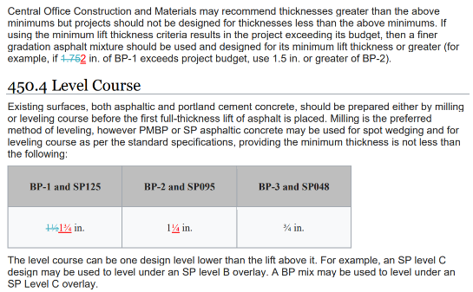

Job Special and General Provision Changes

- JSP-18-01 Supplemental Revisions – several provisions have been removed from the JSP and incorporated into the Standard Specifications (Sec 107, Sec 617.20.3, and 1063). This is effective July 2023.

- JSP-02-06 Work Zone Traffic Management – the Independence Holiday has been changed to a chart to indicate which days work will be suspended. This is effective July 2023.

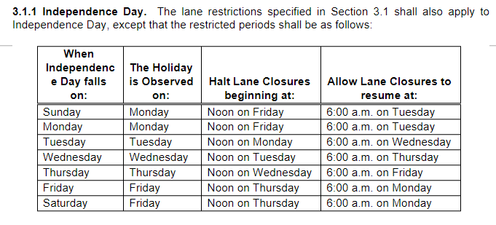

Standard Specification Changes

- Sec 107 Legal Relations and Responsibility to the Public – the entire section has been updated, however most revisions pertain to insurance. This was previously in the Supplemental Revisions JSP from May 2022 to present.

- Sec 401.2.2 Reclaimed Asphalt. Change table regarding binder from “Virgin Binder shall be softened one grade” to “PG 58-28 Virgin Binder shall be required”. Further define what is allowed with recycling limits for the Binder.

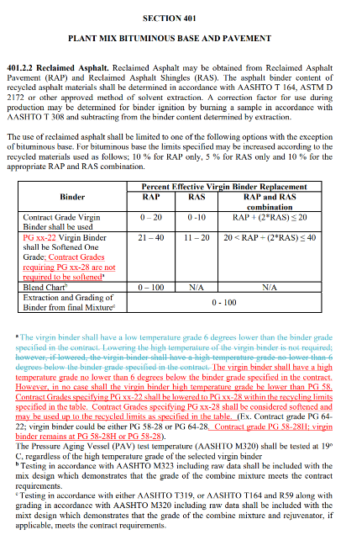

- Sec 402.10.1 Weather Limitations. Change this section to incorporate the “Alternate Weather Limitations” clause that was in the Supplemental Revisions. Added 402.10.1.1 Cold Weather Paving as a new section that defines the actions required to implement.

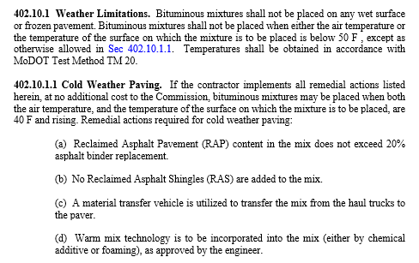

- Sec 409.2.1 Add new section pertaining to contractor and engineer testing frequency for gradation and deleterious.

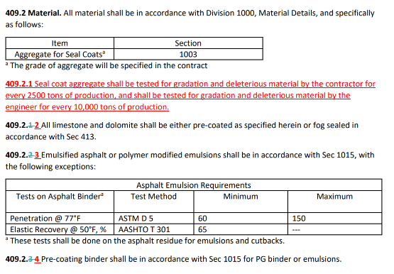

Standard Plan Changes (see plan sheets at the end of this document)

None

Upcoming/Future Revisions

1. EPG 616.8 Typical Applications (TAs), continue to be updated. MoDOT will share when the TAs are complete.

