Minutes
MAPA / MoDOT Quarterly Meeting
August 6, 2024 / 1:00 – 3:00 p.m.
Videoconference / In-person

Agenda Items

- New DBE reporting requirements and associated cost.

MoDOT is piloting a new payment collection software on 6 projects this year. The cost for the software is $1,000 per contract. They are currently using feedback from users to make improvements to the software. They plan to fully implement in January of 2025.

- MoDOT Design Standards Update

See attached handout.

- Bituminous Technical Team Update

A presentation on pelletized RAP was given by Kaley Laleker with Saint Gobain.

MoDOT is considering lowering the effective binder replacement on 401 and 402 mixes from 40% to 30% for RAP and from 20% to 15% for RAS. They will be sending the proposed changes to MAPA for comment.

MoDOT is continuing to work on a Balance Mix Design Question and Answer document for the EPG. They will try to have it completed by January 2025.

MoDOT has asked MAPA to develop criteria to determine when it is necessary re-evaluate the in-place asphalt grade if a significant change is made to the recycled asphalt content.

MoDOT is going to review the current requirements for verification of the gyratory compactor. It was agreed that once per month is sufficient.

- Sec 403.13.1 Paving Widths

MoDOT is planning to clarify the intent of Section 403.13.1. Current wording of the specification combines four different specifications and makes the overall intent confusing.

Action Item: MoDOT will clarify the specification and share with MAPA members for comment.

- GTR in lieu of fibers in SMA Mixtures

MoDOT is currently performing friction testing on pilot SMA projects that are utilizing dry process Ground Tire Rubber (GTR) in lieu of fibers. If test results continue to be favorable, MoDOT expects full implementation of dry process GTR in lieu of fibers in January 2025.

- 30-degree safety wedge requirement

30 degree safety edge requirement. Industry requesting clarification when safety edge should be used and there seems to be inconsistent usage. Federally mandated safety treatment intended for shoulder-less pavements where there is space for a safety slope. The intent is that if aggregate backfill erodes away; a safety edge is there to help mitigate accidents. The Safety Edge is:
• Required any time for shoulder-less pavement or the shoulder is 4 ft wide or less provided the roadway has space to support the safety edge.
• Intended for routes with aggregate shoulders that have edge ruts/etc., but not to narrow the road surface.
• Generally, not done for lettered routes as they don’t have the width to support the safety edge
• Missouri took it a little farther to include paved shoulders if they are 4 feet wide or less
• Typically requires 30° edge on the pavement that is backfilled with aggregate
• NE/CD use a flatter safety edge with no backfill but use a 3 or 4 to 1 slope on the asphalt
• Asphalt Industry to follow up with other states on what they call their equivalent treatment, if they call it something else than “Safety Edge”. Concerns of liability of calling it “Safety Edge”.

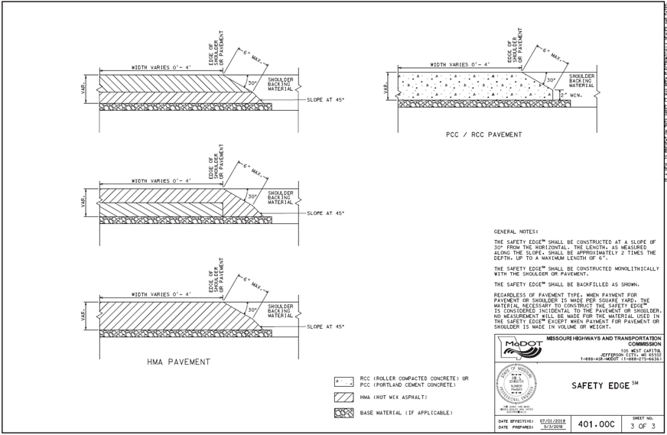

- Closing routes 20-feet or less for paving and edge treatment operations.

MoDOT currently has a JSP that is utilized in the Northwest District with success.

Action Item: MoDOT will review current JSP and develop policy for future projects across the state.

- Testing of Liquid Asphalt to verify contract grade when RAP percentage change. Is this a requirement for all projects when RAP percentages have changed?

This is the same item that was covered by the BIT Team Item Number 2.

Action Item: MAPA will develop recommendations to address changes in RAP percentages and in-place binder grade requirements.

MoDOT will consider allowing performance testing to verify mixes.

- Allow milled surfaces remain open to traffic for up to 48 hours.

MoDOT has experienced many failures and is only open to allowing milled surfaces to remain open in limited conditions.

- FY2025 Low Volume Road Program

Attached is a map along with a list projects for the FY2025 Low Volume Road Program. This program is a result of $100 million from General Revenue (GR) approved during the 2024 Legislative Session.

- New Business

Industry is asking MoDOT to reconsider sharing future paving quantities as it helps industry to plan for future equipment purchases, staffing needs etc. Prior to COVID, MoDOT published annual paving quantities following the approval of the STIP. MoDOT understands the industry’s concerns and is willing to revisit the issue.

Action Item: Develop of team of industry and MoDOT employees to identify the best method to determine asphalt pavement quantities

NEXT MAPA / MoDOT Quarterly Meeting
Tuesday, November 5th, 2024
1:00 p.m. to 3:00 p.m.

Videoconference / In-person

