EPG Guidance for Section 403
ASPHALTIC CONCRETE PAVEMENT with Balanced Mix Design and Performance Testing
This document was developed, and will be maintained, to clarify the intent of the specifications, reduce conflict in the QC/QA environment and improve uniformity of contract administration across the state.
This is not a contract document and cannot be enforced as such. The Resident Engineer always has the latitude to react in an appropriate way to job specific circumstances, but decisions should be consistent with the underlying intent of guiding specifications and policies.

For this discussion, QC refers to the contractor’s representative performing Quality
Control testing. QA refers to MoDOT’s representative performing Quality Assurance testing.

Quality Control is a constant process that goes beyond taking samples required by random numbers. Quality Control is the set of activities that control the quality of mix being produced and placed. These activities include but are not limited to the required random number tests. Quality Control also includes all informational tests on the materials and processes.

Informational Test refers to any testing performed by QC or QA that is not associated with a random number/sample location. These tests are not to be used for PWL purposes.
QUESTIONS AND ANSWERS
- What tests and retained samples are required for the BMD specification?
- LOT Size – 6,000 Tons
- Maximum Sublot Size – 1,500 Tons
- (Each Lot requires at least 4 sublots)

For Quality Control (QC) at one QC BMD Random Test
TEST | FREQUENCY | MIN. NO OF SPECIMENS
QC - CT_{Index} | 1 Set per 3000 tons | 5 Compacted Specimens
QC - RT_{Index} | 1 Set per 3000 tons | 3 Compacted Specimens
QC – BMD Loose Mix Retained | 125 lbs per 3000 tons | Retained by Contractor
QA – BMD Loose Mix Retained | 125 lbs per 6000 tons | Retained by MoDOT
For Quality Control (QC) at one QC Volumetrics/AC Random Test
TEST | FREQUENCY | MIN. NO OF SPECIMENS
QC - % Asphalt Content | 1 Sample per Sublot | 1 Sample
QC - Gmm | 1 Sample per Sublot | 1 Sample
QC – % Air Voids | 1 Set per Sublot | 2 Compacted Specimens
QC – Volumetric/%AC Loose Mix Retained | 30 lbs per Sublot | Retained by Contractor
QA – Volumetric/%AC Loose Mix Retained | 30 lbs per 6000 Tons | Retained by MoDOT
For Quality Control (QC) at one TSR Random Test
TEST | FREQUENCY | MIN. NO OF SPECIMENS
QC – Tensile Str. Ratio (TSR) | 250 lbs loose mix  per 12,000 tons | 8 Compacted Specimens

For Quality Assurance (QA) at one QA BMD Random Test
TEST | FREQUENCY | MIN. NO OF SPECIMENS
QA - CT_{Index} | 1 Set per 12,000 tons | 5 Compacted Specimens
QA - RT_{Index} | 1 Set per 12,000 tons | 3 Compacted Specimens
For Quality Assurance (QA) at one QA Volumetrics/AC Random Test
TEST | FREQUENCY | MIN. NO OF SPECIMENS
QA - % Asphalt Content | 1 Sample per 6000 tons | 1 Sample
QA - Gmm | 1 Sample per 6000 tons | 1 Sample
QA – % Air Voids | 1 Set per 6000 tons | 2 Compacted Specimens
For Quality Assurance (QA) at one TSR Random Test
TEST | FREQUENCY | MIN. NO OF SPECIMENS
QA – Tensile Str. Ratio (TSR) | 250 lbs loose mix per project | 8 Compacted Specimens

- 13x13x4.5-inch cardboard boxes are required for any QA retained loose mix and TSRs. Boxes supplied by MoDOT since it is for QA testing.
- No container size requirement for QC retained samples.
- BMD Retained Samples
  - Contractors and MoDOT Districts retain BMD loose mix until passing QC and QA RT results are obtained at which time they can be disposed of.
      - BMD QA retained loose mix sent to MoDOT Central Lab for Hamburg testing if failing QC or QA RT_{Index} results.
      - BMD QC retained loose mix tested by Contractor for Hamburg testing if failing QC or QA RT_{Index} results.
- Volumetric/% AC Retained Samples
  - Contractors and MoDOT Districts retain Volumetric/% AC loose until comparable QC/QA results are obtained.
  - Retained material used for retest when QC/QA samples fail to compare.

- How are random numbers used with BMD sampling and testing? What goes with what?
  - 8 Different Random Numbers are generated based on tonnage.

One Random Number Generated for Each of Below Tests
Test | Tonnage
QC - CT and RT Testing | 3,000 Tons
QC - Volumetrics and % AC | Sublot Size -Set by QC Plan
QC - TSR | 12,000 Tons
QC - Mat Density & Unconfined Longitudinal Joints | Sublot Size -Set by QC Plan
QA - CT and RT Testing | 12,000 Tons
QA - Volumetrics and % AC | 6,000 Tons
QA - TSR | Once per Project
QA - Mat Density & Unconfined Longitudinal Joint | 6,000 Tons

- Typical Unconfined Longitudinal joint random numbers
  - To limit work zone exposure, the same random number is used on Unconfined Longitudinal Joints as Mat Density.
- What if the paving is such that the unconfined longitudinal joint is intermittent?
  - A separate unconfined longitudinal random number should be generated prior to starting the project based upon a separate estimated tonnage of the intermittent unconfined longitudinal joint.
  - Pay adjustments will only apply to the full width of the lane paved adjacent to an unconfined joint.
  - (Add in minimum length required) ….. Small areas in and out would be difficult.
- What happens if random numbers fall at the same time?
  - Testing will be conducted in order received. The contractor will be allowed to complete the first test, then immediately sample for the 2nd test.
  - The contractor can choose to hold on to loose mix sample for volumetric test until after the BMD testing is completed.

- If a random number falls at the end of the paving shift, can the sampling and fabrication of performance test specimens be moved up so that there is sufficient time for completing the sampling?
  - Yes. Due to the amount of time and effort involved in BMD testing, the inspector needs to ensure there are at least 2 hours left in the shift at the point when BMD sample is taken so there’s enough time to fabricate the CT and RT test specimens.
  - Inspectors need to estimate a production rate for that day and estimate a 2-hour tonnage adjustment for the BMD testing.

- Is sampling from multiple trucks allowed?
  - Multiple truck sampling is not allowed. It was determined that this was not needed.

- How much notice needs to be given for BMD testing at the plant?
  - (Reword for finishing contractor’s other testing being conducted)

- When is split sample testing utilized?
  - Split samples are used to ensure that the proper sampling, handling, and testing procedures are being followed by both QC and QA so that accurate results are obtained, and favorable comparisons are achieved.
  - In addition, if QA missed witnessing a QC sample; the QA may request to test the retained portion as a check since no inspection was done.
- How does MoDOT use informational test results taken outside of random numbers or general testing requirements outlined in the specification?
  - Used to test isolated quality of areas that QC/QA random tests do not capture.
  - Can be used to identify, quantify, and determine limits of any needed corrections.
  - Informational test has no impact on pay factors; except the total tonnage may be adjusted if any removal/replacement is necessary. Otherwise, no deducts can be given on informational test results.
  - (Address beginning of day – 150 tons?)
- Procedure for when QC and QA CT Index results do not compare:
  - Favorable Comparison - QA and QC CT_{Index} results shall be within ± 30 points for SuperPave and +/- 60 points for SMA.
    - For the CT_{Index} test, if all QC and QA are greater than 80 for SuperPave mixes and greater than 190 for SMA mixes, then results are considered comparable regardless of difference.
    - QA RT_{Index} results shall be within ±15 percent of the QC testing that falls nearest. Run Hamburgs if they don’t compare.
  - Follow current procedures to check for sampling or testing errors by either party.
  - If no errors are determined, then QA result will be added to the QC results to include in the average.
  - CT_{Index} Reheated samples will not be used for dispute resolution due to the sensitivity of the test.
  - CTIndex test specimens older than 2 weeks will also not be used.

- Scenarios on how to pay for Section 403 mixes and Density requirements.
  - Assume Plan sheets show SuperPave on 4 ft inside shoulder and 2 ft outside shoulder.
2 ft Shoulder
Inside Shoulder
BP Mix
SuperPave

Remaining Shoulder Width

16’ Pave Integrally

  - Scenario 1: Where contractor paves wider with the Section 403 mix than is on the plans.

For example, paving 16 feet wide when the plans show the Section 403 mix is only 14 feet wide. In this case the Section 403 mix extends two feet into what plans sheets show as shoulder mix.
    - Calculate quantity placed within the Section 403 limits and pay as Section 403 mix.
      - Density, % AC, VMA, % Av, TSR, and/or BMD incentive/disincentive pay would only apply to quantity placed within the Section 403 limits ~ 14 ft wide.
    - Calculate quantity of Section 610 quantities on the 12-ft travel way for smoothness.
      - Smoothness incentive/disincentive would apply only to the 12-foot travel way.

  - Scenario 2: What densities apply?

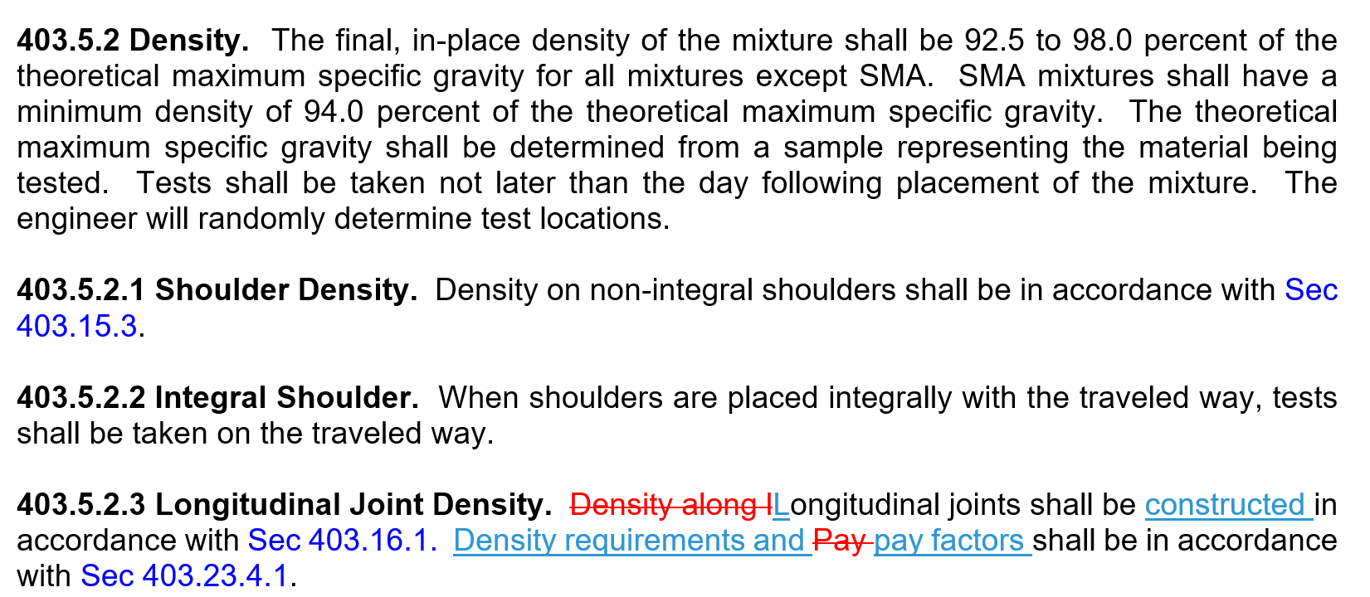

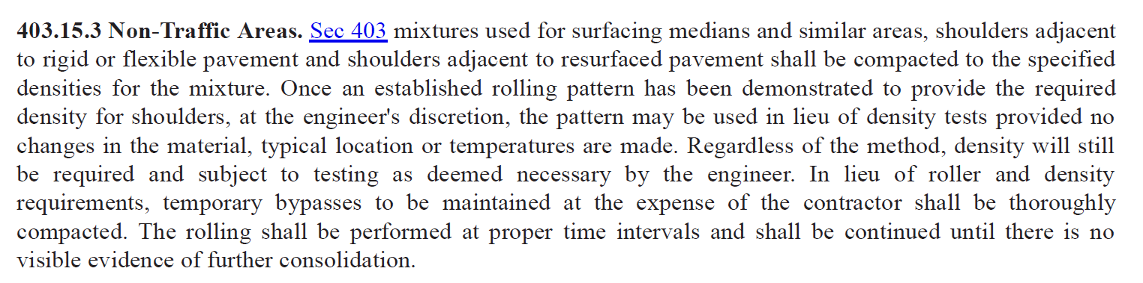
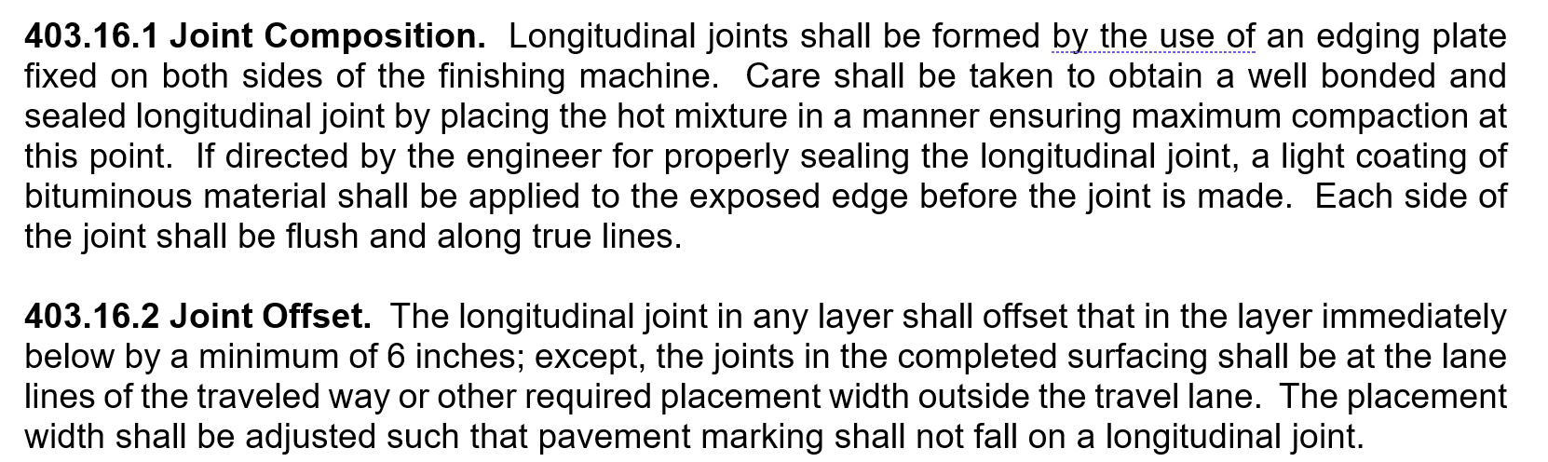
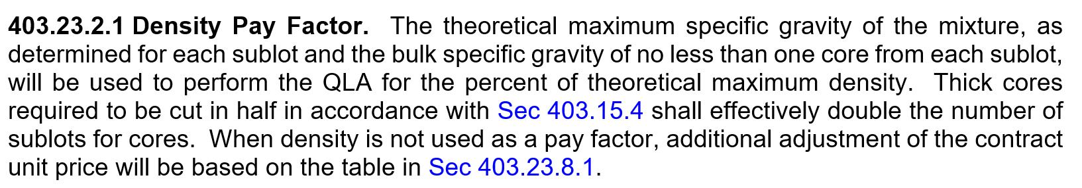

403.5.2 Density. The final, in-place density of the mixture shall be 94.5 ± 2.5 percent of the theoretical maximum specific gravity for all mixtures except SMA. SMA mixtures shall have a minimum density of 94.0 percent of the theoretical maximum specific gravity. The theoretical maximum specific gravity shall be determined from a sample representing the material being tested. Tests shall be taken not later than the day following placement of the mixture. The engineer will randomly determine test locations.
- Unconfined joint density cores
  - When are they taken?
    - With mainline core
  - Unconfined Joint cores on outside edge
    - If shoulders and the traveled way are placed integrally, (12ft lane paved at 13.5ft) an unconfined density core is not needed
  - How to handle failing density cores
    - In
- If the contractor performs a corrective action such as using a penetrating oil – are they eligible for full bonus?
  - As written, corrective action gives 100% pay. Uncertain on the performance of RPE products in being as good or better than achieving full density~needs revisiting.
  - If they mill and replace do, they get full bonus?
    - Yes, addressed in the specification.
  - How much of the longitudinal joint would need corrected?
    - Entire sublot is required to be corrected.

- When new asphalt is required to be removed and replaced, is new BMD testing required for that asphalt?

Example Question: I have a BMD question for you. We have a possible scenario coming up and I am trying to find guidance. On the I-44 we have tack coat issue that the RE is deciding if we need to mill out the entire nights production. On the night of production which was 1500tons, 2 volumetric randoms were pulled, 2 random roadway cores were cut, and the QA Performance random was pulled. I know that the volumetric randoms and the cores will need to be repulled and the values replaced due to the mix being replaced. My question is, will the BMD samples also need to be repulled? We are still within the 20000 lot for the QA sample. I was thinking since the reason the mix is being milled out is not a mix issue but something else, that the BMD is still representative of the lot it was pulled, and we could leave that test in place and just do the retest on the volumetrics and the cores? What do you think? It has still not been decided if the mix is being milled out or not.
Relate to small quantity and do volumetric only.
Example Answer:
In this case the mix is being milled out due to a tack coat issue and not mix issue and QA is tested 1/20,000 tons under the JSP for the job. I would be ok with proceeding with the current QA BMD test result. Under the old JSP where CT/RT index is tested at 10,000 ton frequencies that matches the TSR testing frequency. We should probably treat the QA BMD test the same as we would a QA TSR sample in this scenario.

If this were a TSR sample I don’t think we would get another sample. EPG guidance only addresses volumetrics, so I’d imagine historically when this issue comes up we have not gotten a new TSR sample.

- Contractor equipment for CT index – hydraulic or screw driven? Does the department have a preference?
  - No specification requirement,
  - Humbolt manufacturer customer service not good and test results were questionable.

- Binder source changes - 2 options
  - If the virgin binder source changes but the virgin binder grade is the same, the mix ID remains the same but an “A” gets added as we currently do
  - If the virgin binder grade changes a new mix ID and JMF are required.
    - If the contractor wants to use a mix for two different contract binder grades, then a separate mix ID and balanced mix design test results are required for both contract binder grades.
For example, a contractor wants to use a single mix design for both PG70-22 and PG76-22 then two mix design IDs will be issued. Balanced mix design test results showing the mix meets both contract binder grades will need to be submitted as well.
BMD testing results only, not entire volumetric analysis.
- If CT index tested at 1/3000 tons, how many tests are needed for 3200 tons? 4600 tons?
  - If final tonnage falls within 1,000 tons of a 3,000 ton sublot then the tonnage can be combined into one lot.

  - Staged construction (bridge ends, etc.) how do those get treated?
    - How would small quantity acceptance tie in (<6000 tons 403.20.1)
Last sublot up to 1.5 times (4500 tons).

- If TSR tested at 1/12000 tons, how many tests are needed for 13000 tons? 15000 tons?
  - If final tonnage falls within 6,000 tons of a 12,000 ton TSR lot then the tonnage can be combined into one lot.
  - If final tonnage exceeds 6,000 tons over a 12,000 ton TSR lot then an additional TSR test shall be ran.
  - Less than 6000 tons roll it into previous lot.
- Small quantity (<6000 tons) portion of the spec
  - < 1000 tons requires one per day, what’s the most tons of asphalt we would allow without requiring a test (volumetric)
  - EPG allows 50 tons per day and up to 250 tons per project
  - Subject for more internal discussion, if contractor producing only 500 tons/day, production is not consistent, multiple starts and stops during the day where chasing volumetrics may cause more trouble than its worth
  - Address overruns in plan small quantity ~ continue to treat it as small quantity. A change in scope may lead to some other QC testing plan.
  - Is there a minimum amount to do limited testing? Come up with another testing approach (ie AC only).

- Loss of Data for PMTP/IC due to GPS Obstruction
  - A GPS obstruction form is located in the IC Doc Helper that outlines the protocol to exclude areas of gps obstruction from Veta analysis. The intent is to not penalize contractors for GPS obstructions, but proper documentation needs to be completed.

- How to handle segregation identified by the PMTP
  - The Veta file may be used as a tool by the RE/Inspector to locate areas of segregation on the roadway. A visual verification of segregated areas on the roadway should be performed before any remedial actions are required. In general, if the segregation is not visible then remedial action is not warranted.
  - The nuclear density test method outlined in the specs should be a last result for the RE/Inspector but should be used if segregation is believed to be severe enough.
  - In an event of a dispute, segregated areas must be quantified by nuclear density method.

- PMTP Loss of Data due to equipment malfunction
  - The contractor is required to make a reasonable effort to resolve the issue immediately. However, if the contractor is not able to resolve the issue immediately, they may continue paving without the possibility of receiving incentives for the PMTP data.
  - If the issue you last for multiple days, it is recommended that the RE talk to the manufacture to see how long a replacement can be provided to the contractor. If the contractor does not have a replacement PMTP by the date suggested by the manufacture, then the contractor shall not be allowd to continue paving until the PMTP is replaced.

- Nuclear density testing – clarification of how to implement TM-41 and when go to coring
  - Contractor has the option to use nuclear density testing in leu of coring for density bonus but QA would still require a core that the contractor would be required to cut.

