Remote Truck Sampling Device (RTSD)

1.0 Description. This special provision includes the description of work to be performed for installing and implementing a Remote Truck Sampling Device (RTSD) for retrieving loose mix asphalt samples from a truck at an asphalt plant for Balanced Mix Design (BMD) testing.

2.0 General. The RTSD will be Commission furnished and Contractor retained. The contractor is responsible for picking up the device, transporting, protecting the control unit from the elements, and meeting all equipment manufacturer installation requirements for implementing the RTSD equipment for this project.

2.1 The contractor shall pick up the RTSD from the MoDOT Central Office Facility no later than 30 days following the Notice to Proceed. The contractor will be charged liquidated damages $250 per day for each day the RTSD is stored at the MoDOT facility beyond the date of Notice to Proceed.

2.2 The contractor shall arrange RTSD pick-up from MoDOT Central Office Facilities located at 830 MoDOT Drive, Jefferson City, MO 65109. The pick-up date and time shall be pre-arranged with MoDOT General Services Manager as follows:

Scott Emmerich
General Services Manager
Office: (573) 526-7937
Cell: (573) 616-8583
Scott.Emmerich@modot.mo.gov

2.3 The contractor shall be responsible for the RTSD unit immediately after pick-up. Any damages to the RTSD occurring after pick-up shall be at the expense of the contractor for replacement.

2.4 The RTSD shall become the property of the contractor after project completion. MoDOT has intent to require use of an RTSD, at no additional cost to the Commission, on future BMD projects; therefore, it is advisable for the contractor to retain this equipment.

3.0 RTSD Installation Requirements. The RTSD installation shall be in accordance with the equipment manufacturer’s specifications and as described herein. The equipment manufacture may be contacted for specific equipment questions as follows:

Pavement Technology, Inc.
7129 Wheat Street
NE Covington, GA 30014
wadec@pavementtechnology.com
(770) 388-0909

3.1 A designated work area shall be dedicated to the RTSD. The work area shall satisfy the safety needs of QC and QA inspectors to safely retrieve asphalt from a truck, handle the loose mix material, and move the loose mix material to the QC/QA on-site laboratory for BMD sample fabrication.

3.2 Electrical Requirements. The RTSD requires a 480 Volt, 60Hz, 50amp, 3-phase electrical hook-up. The electrical hook-up shall have safe clearance from the telescoping arm.

3.3 Foundation Pads. The RTSD requires a level area with the following minimum foundation requirements. Final design and construction requirements to meet RTSD installation needs shall be the sole responsibility of the contractor.

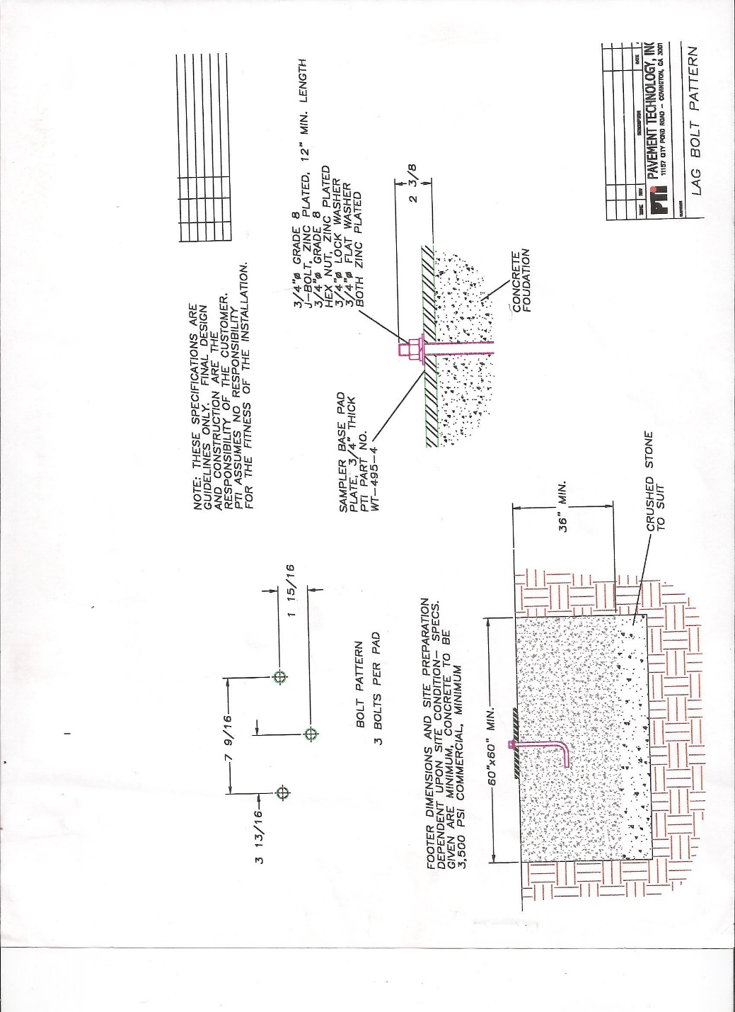

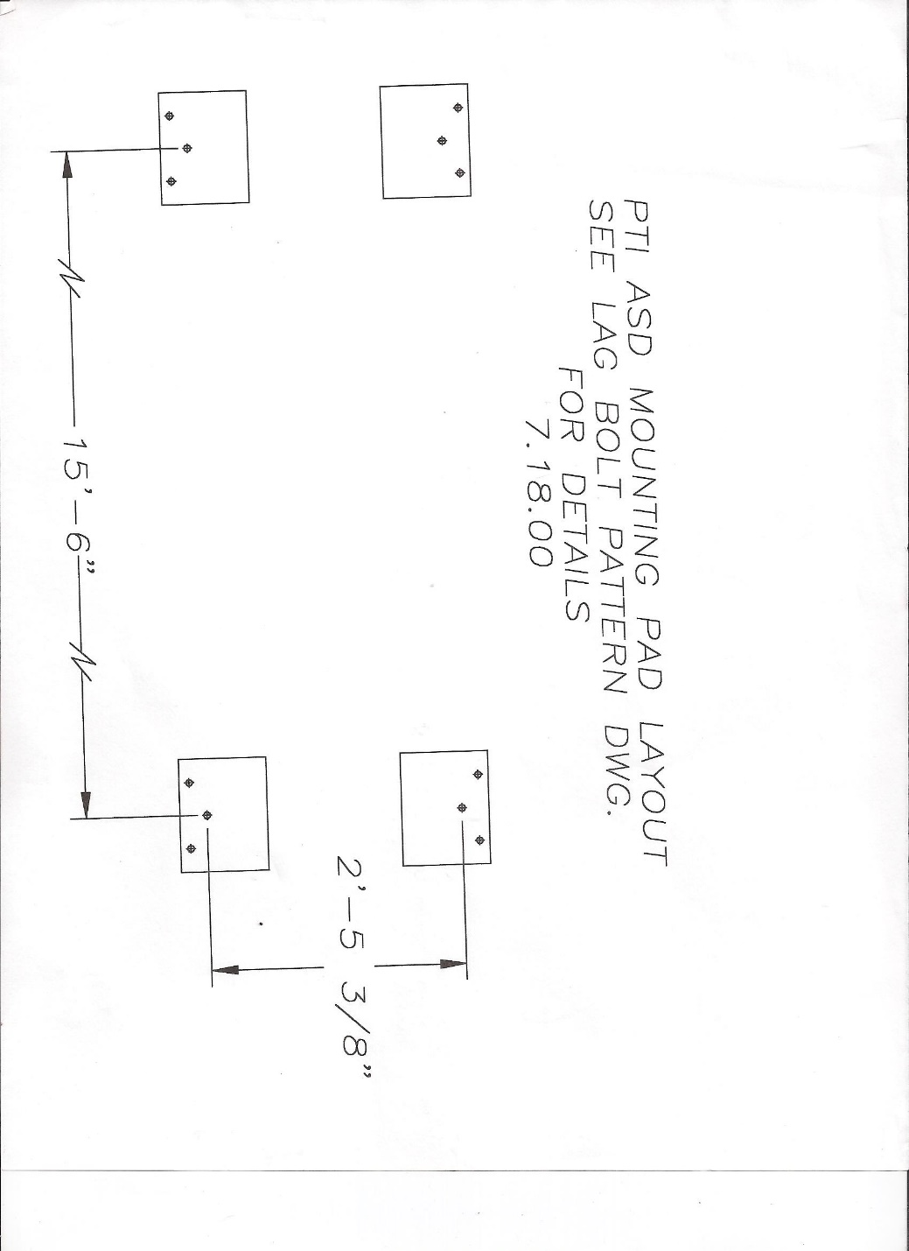

3.4 RTSD Component Description. The Remote Truck Sampling Device (RTSD) safely captures a representative, repeatable, non-segregated sample of asphalt from a haul vehicle and deposits the sample into a specimen container.

The RTSD incorporates a “Telescopic Probe” which captures the sample inside the hump of Hot Mix Asphalt. The probe can traverse forwards and backwards and up and down. The angle of the probe can also be changed.

The probe has (2) 1100-watt cartridge heaters which heat the probe and maintain the preset temperature of the probe while capturing a sample. The probe also utilizes a “Stainless Steel” gate that opens and closes inside the hump of mix. The RTSD can extract a sample from a fully loaded truck as well as a partially loaded truck.

An elevator (mounted to the steel upright) is used to transport the sample from the probe head to ground height. Typical sample size is 50 to 60 lbs and can be captured in approximately 1 minute.

The RTSD unit has the following features:
- Steel Uprights and Cross Members
- Heated probe with Stainless Steel Gates
- Elevator for transporting Hot Mix Asphalt Sample to Ground Height
- Hydraulic Pump, Hydraulic Lines, and Cylinders
- Operator Stand with Operational Controls

Dimensions of the RTSD unit are as follows:
Width: 2.74 m (9’ - 0”)
Depth: 7.30 m (23’ - 10”)
Height: 5.36 m (17’ – 6”)
Weight: 5,443 kilograms (12,000 pounds)

The RTSD can provide an asphalt sampling size of 6.80kg – 27.21kg (15 – 60lbs).

The RTSD Components are described as follows:

Probe Assembly
Solid Steel “Duckbill” Heated Probe Mounted on a Hydraulically Controlled extraction arm. Stainless Steel gates capture the asphalt sample inside the hump of hot mix asphalt and places it in a specimen container or sample splitter.

Probe Heating System
The Probe utilizes two (2) 1100-watt cartridge heaters that are placed in “Gun Bored” holes inside each “duckbill”. The probe maintains temperature between 149C - 205C (300 – 400F).

Elevator
Used to transport hot mix asphalt specimen from probe to ground height. The specimen container sits atop the elevator. A sample splitter may also be utilized and sit atop the elevator.

Operator Stand/Stairs
Allows a User to gain access to the RTSD Controls for operation.

Controls
The RTSD is hydraulically controlled and allows the user to position the probe inside an open transport vehicle and safely obtain a representative sample. Manual Controls are used to maneuver probe head.

Photos
The following photos illustrate the RTSD Components and example set-ups.

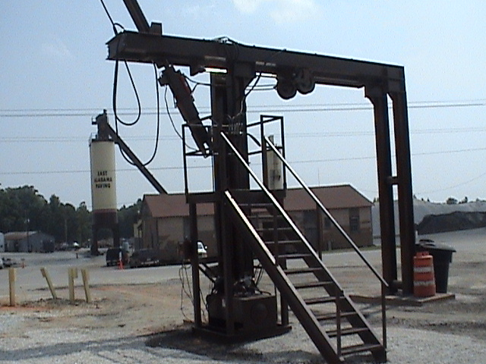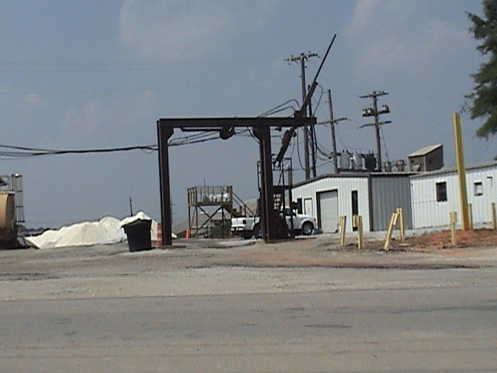

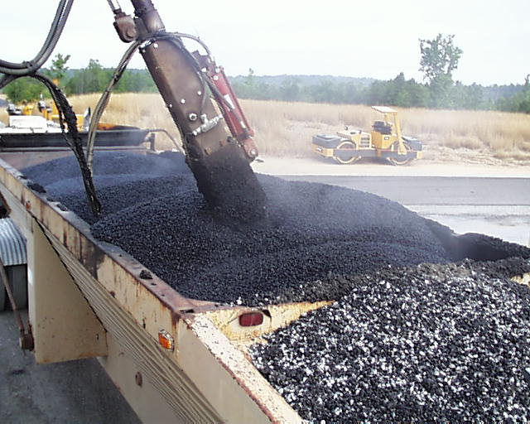

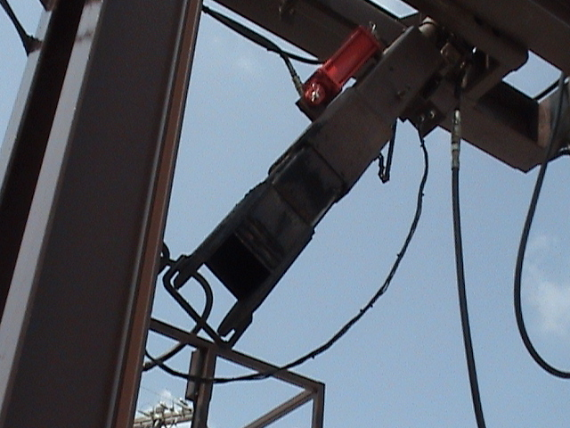

4.0 Construction Requirements. The contractor shall be responsible for training all personnel on using the RTSD. The contractor shall have the RTSD unit installed and fully implemented with properly trained personnel prior to the start of asphalt work in calendar year 2026. Use of RTSD prior to January 1, 2026, is optional.

4.1 The use of the RTSD as specified in Section 4.0 is only required for Balanced Mix Design sampling.

5.0 Basis of Payment. The RTSD will be furnished by the Commission. Payment for transporting, storing, electrical, foundation, operation, maintenance, and training of personnel necessary for RTSD implementation of the RTSD will be made at the lump sum contract unit price for Item No. 403-99.01, RTSD Installation. No additional payment will be made for any other incidentals necessary for RTSD implementation.

