Meeting Minutes
MAPA / MoDOT Quarterly Meeting
May 6, 2025 / 1:00 – 3:00 p.m.
Videoconference / In-person

Agenda Items

- Bidder’s List Quote Update

For the April 18, 2025, Letting, MoDOT received the submittal from all bidders, including some for state-funded projects where the form/submittal is not a requirement. This form submittal with the bid is only necessary for those projects that are federally funded; project funding is delineated in the JSP’s.

The most common issues were not indicating “Y” or “N” on whether they used the quote provided, or submitting the incorrect form, as there is a similar but different form for LPA projects.
  - For MoDOT projects, contractors should be submitting the Bidder’s List Quote Summary form found on the MoDOT Online Plans Room “second page,” better known as the “Bid Opening Info” page.

  - The correct form is a Microsoft Excel spreadsheet with a MoDOT logo in the upper left corner of the form. The LPA form is a Microsoft Word text document and has no logo.

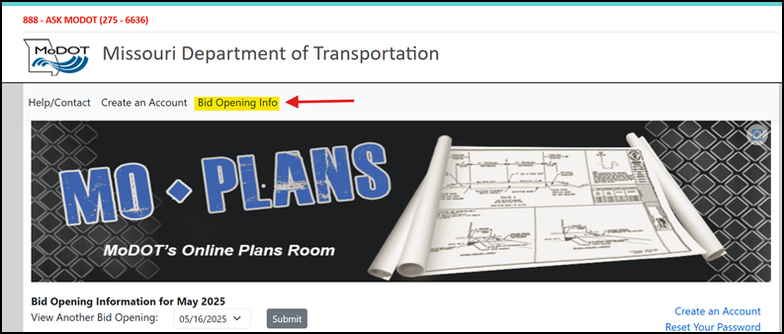

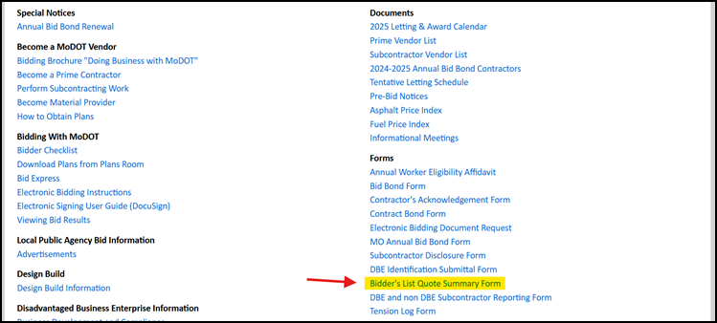

Here’s what the correct form looks like:
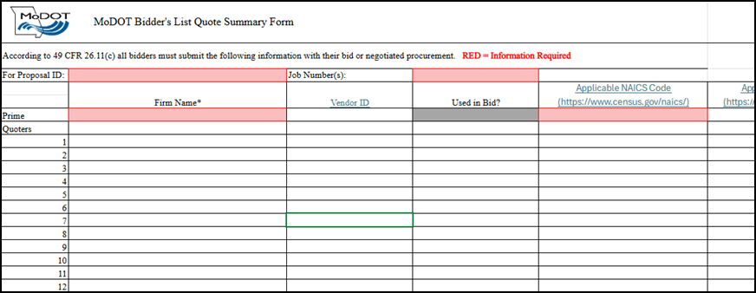

- MoDOT Design Standards Update

See attached Design Standards Update

- Follow up on Action Items from Jan Meeting

  - Asphalt flushing/bleeding issue
MoDOT Field Office is collaborating with the Southeast District on the I-55 overlay project (J9I3838, Cape Girardeau US-61 to MO-74). MoDOT is targeting a January 2026 letting and will issue the research RFP by the end of June. The standard surface course will be a 1.5-inch SP095B mix with PG 76-22 binder, and four 0.2-mile test sections will evaluate bleeding reduction in an SMA mixture:
- SP095B SMA w/ PG 76-22, designed to Balanced Mix Design (BMD) thresholds
- SP095B SMA w/ PG 76-22, BMD thresholds plus required manufactured screenings
- SP095B SMA with a Hi-MOD asphalt binder (if feasible)
- SP095B surface course with a Hi-MOD asphalt binder
  - 2025 asphalt binder sampling improvements

On May 22, 2025, MoDOT will review proper asphalt binder and emulsion sampling procedures with its Construction and Materials staff.

  - Sec 1015 changes for REOB, VTAE, and PPA.

Sec 1015 changes for REOB, VTAE, and PPA approved and are effective July 2025 Letting.

MoDOT will be sending out a letter to all approved suppliers on the 1015 specification change. Any supplier who violates the 1015 specification will be subject to removal from MoDOT’s approved list.

MoDOT Chemical Lab is working on implementing Quantitative Analysis of Asphalt Binders for Recycled Engine Oil Bottoms (REOB) TP xxx-26 as part of the asphalt binder qualification process and is still working to a test method procedure of detecting Vacuum Tower Asphalt Extender (VTAE) presence. REOB detection will be conducted on a limited “spot checking” basis due to the time and effort involved.

The contractors need to verify with the asphalt suppliers the material they are getting is compliant with MoDOT specifications. It is not currently practical for a QC/QA production sampling and testing process for REOB or VTAE detection.

ACTION ITEM: MoDOT to develop test methods for detecting REOB and VTAE.

  - Minimum lift thickness

Based upon the meetings discussions, the draft revision has been revised as follows.

403.13 Spreading and Finishing. The base course, primed or tacked surface, or preceding course or layer shall be cleaned of all dirt, packed soil or any other foreign material prior to spreading the asphaltic mixture. If lumps are present or a crust of mixture has formed, the entire load will be rejected. The thickness and width of each course shall conform to the typical section in the contract. The contractor may elect to construct each course in multiple layers, with minimum compacted lift thicknesses equal to 4 times the nominal maximum aggregate size, unless otherwise shown on the plans. The minimum compacted lift thickness for the top lift surface course shall be 1.0 inches for SP048, 1.5 inches for SP095, 2.0 inches for SP125, 3.0 inches for SP190, and 4.0 inches for SP250 mixtures.

ACTION ITEM: MAPA to provide comments on proposed specification change.

  - Remote Truck Sampling Device

Goal – Improve safety of sampling out of a truck and retrieve consistent and uniform asphalt loose mix material for reducing variability in BMD testing

PROJECT 1 LOCATION:
Job Number: JSL0073
Route/County: MO 100_St. Louis City
Location: East of Yale Avenue to I-44
Letting Date: May 16, 2025

PROJECT 2 LOCATION:
Job Number: JKU0017
Route/County: I-29_Platte County
Location_0.8 miles south of Mexico Avenue to Rte 69.
Letting Date: June 20, 2025

- Commission Furnished/Contractor Retained
- Pick-up no later than 30 days from NTP Date @ Jefferson City
- 12,000 lbs, Longest Component – 23’ 10” – Low Boy or Flat Bed Trailer typical.
- Keep all electronic components dry until installed.
- Important Contact:
Pavement Technology, Inc.
7129 Wheat Street
NE Covington, GA 30014
wadec@pavementtechnology.com
(770) 388-0909

- No required use until 2026 – Future Research Study - BMD COV between RTSD and standard methods.

  - HiMod Spec Update

MoDOT has placed in a couple upcoming projects and will provide a list. MoDOT is willing to look at full depth designs that accommodates soil and base requirements and open to VE proposals.

ACTION ITEM: MoDOT to provide list of HiMOD Projects and also look for full-depth pilot projects.

  - Re-certification Class Materials

MoDOT to continue working on this item.

ACTION ITEM: If anyone see’s an issue with material or test items, please contact Brett Trautman.

- Bituminous Technical Team Update

See attached meeting minutes.

- Update on upcoming chip seal work

MoDOT announced the launch of a preventative‐maintenance chip-seal program on the Governor’s Minor Road Program, starting with the June letting and encompassing 480 miles later this year. MAPA voiced concern about applying chip seals to newer pavements, given the failures recently observed in the Northeast District.

- Profiler Certifications at ICART

Illinois DOT requests all participants to conform to ICART certification procedures.

  - MoDOT currently requires one pavement type, 7 runs at operating speed, 5 passing accuracy and repeatability comparisons with the “reference profile”.

  - ICART – 3 pavement types,
    - HMA Dense Graded - 5 passes at 25 mph and 5 passes at 50 mph
    - PCCP Transversed Tined – 5 passes at 35 mph
    - PCCP Diamond Grooved – 5 passes at 35 mph
    - Accuracy (90%) and Repeatability (92%)

MoDOT will continue accepting profiler certifications by reciprocity from other entities meeting AASHTO R56 using ProVAL software for certifications and conducting at least one pavement type with a reference profiler. Another surrounding state that qualifies is Arkansas State University located in Pineville, AR. Other states such as Kansas, Iowa, and Nebraska do not meet AASHTO R56 and do not qualify. NCAT and MnDOT are also acceptable reciprocity options.

- Smoothness Specification changes for asphalt overlays less than 1.5-inches

Percent improvement incentives/disincentives only apply on asphalt lifts 1.5 inches or greater. See attached Section 610 proposed specification change.

ACTION ITEM: MAPA to provide comments on proposed specification change.

- Race Tracking – Sec 403.13.1 Revision

See attached Section 403.13.1 proposed specification change.

ACTION ITEM: MAPA to provide comments on proposed specification change.

- JSP – Removal of Dust from Cold Milled Surfaces

MoDOT is planning to pilot a JSP for the Removal of Dust from Cold Milled Surfaces. See attached. The pilot projects are listed below:

Project | Route | County | Tentative Schedule
NE0048 | US 61 | Clark - Canton | Fall 2026
NE0248 | MO 47 | Lincoln - Troy | Fall 2025
2P3396 | MO 15 | Audrain - Mexico | Fall 2025

NEXT MAPA / MoDOT Quarterly Meeting
Tuesday, July 29, 2025 / 1:00 – 3:00 p.m.
Videoconference / In-person

