Bituminous Technical Team Meeting Notes
July 28, 2026 – (9:30 a.m. – 11:30 a.m.)
1617 MO Blvd. Jefferson City, MO 65109
Upstairs Conference Room 201

Topics

- Review October 2026 Specification Updates (See attached presentation slides)
  - Sec 1015 – PPA
    - Limits the amount of polyphosphoric acid (PPA) to 0.25% by weight of binder
    - Comment from industry that other agencies, when requiring MSCR, have % recovery or % elastic recovery – will discuss if MoDOT should consider
  - Sec 406 – PMTP
    - Previous JSP rolled into Specification as Sec 406
    - Small quantity for PMTP may need further explanation in the specification
      - PMTP might not work well in staged construction, small quantity, etc.
  - Sec 403 – BMD
    - BMD JSP was incorporated into Sec 403
    - MoDOT allowed the transfer of previously approved SP190/SP250 mixes with 4% air voids to contracts requiring 3% air voids
      - An approved SP190/SP250 mix with either 60 gyrations or 80 or 100 gyrations can be transferred to contracts with the new spec until the mix expires
    - Discussion that the BMD gyrations should be “minimum 60” instead of equal to 60 as presented
      - * After the meeting concluded, it was verified that this was included in the final Sec 403 language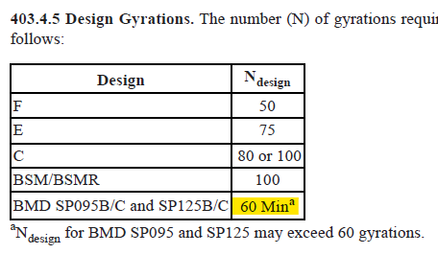
    - RT index vs. Hamburg results for mix design approval
      - Allowing the HWT to govern if the RT doesn’t meet minimum
    - Discussed changing the testing frequencies:
      - Can the frequency of QC gradation be reduced to 1/lot - will consider
      - Consider adding PMTP guidance for small quantities in Sec 403
    - Change to adjustments spreadsheet
      - Allow variable target for minimum RT index
- RT/HWT Correlation
  - Intent is to run the HWT and compare against the RT index
  - If RT index = 58, RT > 58 ok, if RT = 52 then you re-run the HWT
- Review January 2027 Proposed Specification Update
  - Sec 410 – Single Lift Overlay
    - Clarified when single-lift overlay requirements apply based on the depth of cold milling
      - If < 1” cold-milling the spec applies the smoothness requirements of a single-lift overlay (“scratch mill & overlay”)
      - Concern was mentioned that % improvement with a “scratch mill & overlay” may be problematic if the road was relatively smooth before the project. Hard to get a 30% improvement if the road is already smooth (IRI < 80)
    - Re-worded specification for clarity otherwise
- Other Topics
  - Were there any Hi-Mod binder specification changes?
    - Hi-Mod not in specification yet, no updates to the Hi-Mod JSP at this time

